SME of the Year 2016

Application Form

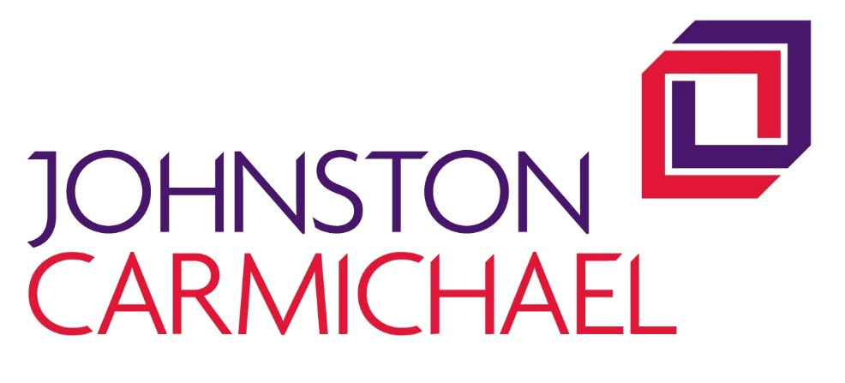

To enter, your business must have fewer than 250 employees and have a turnover of less than £37m. Please complete each section which includes information about the background to the business, the markets it operates in and the business vision.

Please submit to smedcraf@moraychamber.co.uk

Closing date for submitting application forms is noon Friday 7th October

The winner will be announced at the Moray Chamber of Commerce Annual Awards Lunch at The Stotfield Hotel, Lossiemouth on 16th November, at which the award will be presented

Section 1. Business Details
Full trading name of business:
Registered name if different from above:
Date business established:
Address:
Telephone:
Website:
Main contact name and position:
Name of person submitting application:
Email:

Type of organisation and sector (X all that apply):

 | Creative Industry
 | Food & Drink |  | Limited Company
 | Life Sciences |  | Partnership
 | Manufacturing |  | Social Enterprise
 | Renewables |  | Sole Trader
 | Retail
 | Service |  | No. of Employees

Please give a brief overview of your business including details of your customers, the products and/or services that you supply to them and the markets in which you operate
Max 150 words

Section 2. Category Questions

Q1

Please outline the overall trend in your sales turnover and profit, together with a description of how your business has developed.

Q 2
Please highlight your business aspirations and how you might achieve them over the next 3 years

Q 3

What makes your business stand out from the competition and why you think your business should win ‘SME of the Year’ Award?

Authorisation

Name:
Position:
Date:

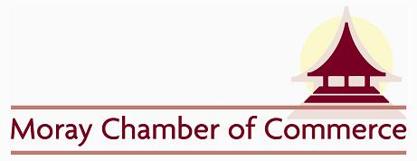
Application Guidelines

Moray Chamber of Commerce are proud to present the Annual Business Awards 2016. The awards provide an opportunity for businesses across the region to promote their achievements and for the business community as a whole to celebrate their success. Applications are open to members and non-members of Moray Chamber of Commerce.

How to enter

It is FREE to enter and you can either apply yourself or recommend a third party business.
Go to www.moraychamber.co.uk and follow the links for the Annual Business Awards Dinner and you will find the application forms. Complete the application form and send back to smedcraf@moraychamber.co.uk by Friday 7th October

The Rules

1. The awards are open to all businesses in the Moray area.
2. All third party nominations must be made with the full knowledge and cooperation of the nominee.
3. Applications can be made for more than one category.
4. Completed forms must be signed
5. Judges must declare an interest should they have links with any nominees
6. Finalists and winners are invited to participate in interviews and photo shoots.
7. Moray Chamber of Commerce reserves the right to not make an award in any category if no satisfactory nominations are received.
8. Previous recipients of an award may apply
9. The closing date for entries is Friday 7th October
10. The judges’ decision is final!

